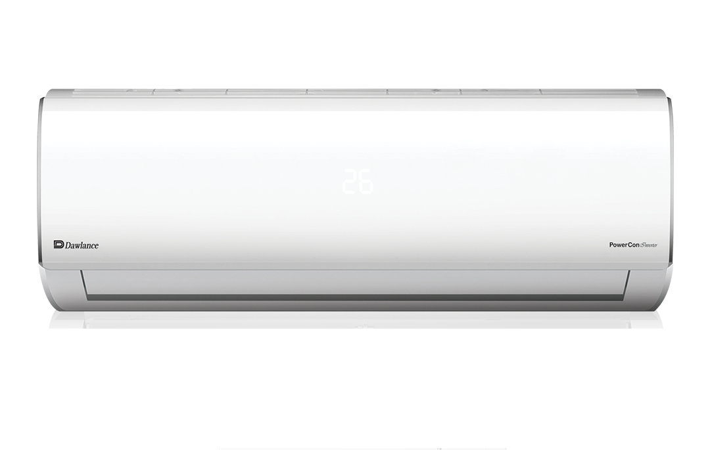

POWERCON 30

Heat & Cool Enhanced Performance of Your AC.

**₨ 128,800.00**